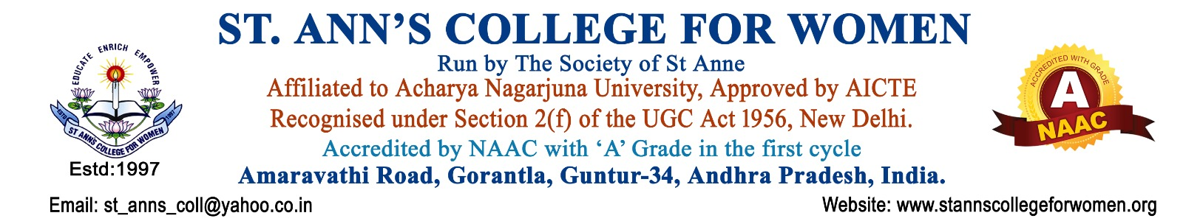

B.Com. Honours (Computer Applications)
Empowering Commerce with Digital Technology
The B.Com. Honours (Computer Applications) programme is designed to equip students with a strong foundation in Commerce along with advanced computer application skills. The programme integrates accounting, finance, taxation, management, analytics, database technologies, web applications, and software tools to prepare students for successful careers in the business, finance, and IT sectors.
Students gain practical exposure through computer laboratories, application-oriented learning, and industry-focused training that help them develop professional, analytical, and technical competencies required in today’s competitive world.
Note: St. Ann’s College for Women presently offers the B.Com. Honours (Computer Applications) programme as a Three-Year Degree Programme in accordance with the guidelines of Acharya Nagarjuna University and the Government.
Programme Objectives
- Build strong foundations in Commerce, Accounting, and Management
- Provide practical knowledge in Computer Applications and Information Technology
- Develop analytical, technical, and problem-solving skills
- Prepare students for careers in Banking, Finance, IT, Business Analytics, and Entrepreneurship
- Encourage higher education and professional career advancement
Programme Highlights
The programme offers a perfect blend of Commerce and Technology through industry-oriented subjects and practical learning experiences.
Key Courses Offered
- Business Organization and Management
- Financial Accounting & Corporate Accounting
- Cost and Management Accounting
- Business Statistics
- Income Tax & Financial Planning
- Database Management System
- E-Commerce and Web Application Development
- Fundamentals of Information Technology & Office Automation
- Data Science using Python
- Business Analytics using Excel & Power BI
- Business Intelligence Tools and Data Visualisation
- Accounting Information System
- Entrepreneurship & Start-Ups
- Auditing & Financial Institutions and Markets
Practical Skill Development
- Computer Application Practical Labs
- Database and Web Development Training
- Python Programming and Data Analytics
- Business Intelligence & Power BI Tools
- Industry-oriented Software Applications
Business Management (Minor)
The Business Management Minor programme provides students with essential managerial knowledge, leadership abilities, communication skills, and practical understanding of business operations. The curriculum is designed to strengthen professional competencies in management, marketing, finance, and human resource development.
Minor Courses Offered
- Principles of Management
- Organisational Behaviour
- Marketing Management
- Human Resource Management
- Financial Management
- Managerial Communications
Minor Programme Highlights
- Foundation in Business and Management Concepts
- Leadership and Team Management Skills
- Marketing and Financial Management Knowledge
- Human Resource and Organisational Development
- Professional Communication Skills
- Industry-oriented and Career-focused Curriculum
Career-Focused Learning
The programme prepares students for careers in:
- Accounting & Finance
- Banking & Financial Services
- Business Analytics
- Data Analytics
- IT & Software Services
- Taxation & Auditing
- Entrepreneurship & Start-Ups
Career Opportunities
Graduates of B.Com. Honours (Computer Applications) can explore opportunities in:
- Accounting and Finance
- Banking and Financial Services
- Business Analytics
- Data Analytics
- Software and IT Services
- Web Application Support
- Tax Consultancy
- Entrepreneurship and Start-Ups
Career Roles
- Accountant
- Auditor
- Business Analyst
- Financial Consultant
- Computer Programmer
- Database Administrator
- Mobile App Developer
- Tax Consultant
- Software Support Executive
Higher Education Opportunities
Students can pursue:
- M.Com
- MBA
- MCA with Maths Background in Intermediate
- CA / CMA / CS
- Professional IT & Data Analytics Certifications
- Specialized Courses in Finance, Analytics, and Management
Why Choose St. Ann’s College for Women?
- Experienced and student-friendly faculty
- Industry-oriented curriculum
- Practical computer laboratory training
- Skill development in Python, Power BI & Data Analytics
- Career-focused learning environment
- Opportunities for internships and placements
- Holistic development with discipline and values
- Guidance for higher education and professional courses
- Placements
Eligibility
- Pass in Intermediate / 10+2 or equivalent examination from a recognized board.

Build a Successful Career in Commerce, Technology, and Business Analytics with B.Com. Honours (Computer Applications).

Contact Us
St. Ann’s College for Women
Gorantla, Guntur – 522 034
Andhra Pradesh
📞 Landline: 0863-2236470
📱 Mobile: 73821 04655, 85006 56134
🌐 Website: www.stannscollegeforwomen.ac.in
Admissions Open for 2025–26
Join B.Com. Honours (Computer Applications) and Build Your Future in Commerce & Technology!

